Boy Scouts of America
Heart of America Council 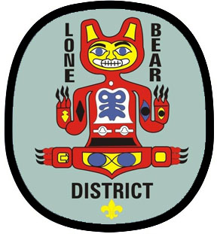

Lone Bear District – Fall Camporee 2023
Bartle Reservation Shooting event.

Boy Scout Troop Registration Form

Troop Unit Number ________________________

Camporee Leader (contact person) __________________________________

Phone__________________for texting Email address ______________________

Address__________________________________________________________________

City_______________________________________ State______ Zip_________________

Boy Scouts participating #__________

Adult Leaders participating #__________

Total Unit participants #__________

Adult and Junior staff (separate count) #__________ Eating with staff? Yes / No

Registration fees @ $7.00 each participant
Troop Registration Fee $10.00 each troop
Staff Registration Fee $00.00 each staff person Covers all meals
Total amount due $__________________ check payable to: HOAC BSA

Amount Paid $______ Check # __________ Date ___________
To pay directly to Council office, use Lone Bear account number: 1-6801-341-20
Additional changes ( day of event) Registration # _________ @ $9.00 ea.

Total amount $ ___________ Make check payable to HOAC
_______________________________________________________________________
Mail registration and fee to: Jon Cerda - 386 NW US 50 Hwy - Centerview, MO. 64019 or bring to Camporee and turn in at check in station.

